LEAN STARTUP MANAGEMENT PROJECT

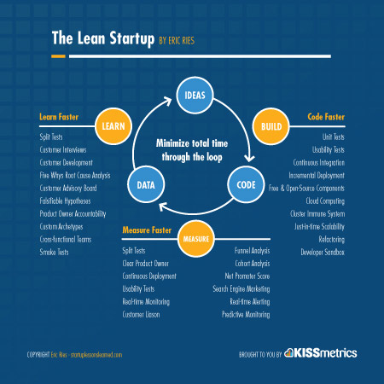

**Winter Semester 2016-2017**

**TOPIC:**

Restaurant Service System

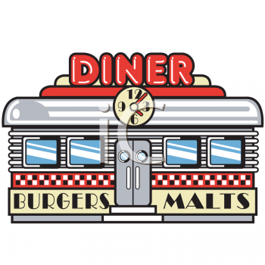

**Teacher:**

Prof.SAMUEL K JOHNSON

**STUDENTS:**

* Osho Agyeya(15BCE1326)
* Kashish Miglani(15BCE1003)
* Utsav Rai(15BCE1352)

I.Product Definition

# Problem Statement

To create a site that automates the process of placing orders and reduces miscommunication and discrepancy that occur during the order process and generates the bill automatically.

# Functions to be provided

1. Login and signup of the user
2. Admin login
3. Order placed from user to admin
4. Bill Calculation
5. Update and recover password
6. Accepting and rejecting customer orders

# Processing environment: hardware/software

1. Notepad
2. Web Browser (Google Chrome 53)
3. XAMPP

# User Characteristics

1. Customer
   * Place order
   * Retrieve password
   * Update password
   * Login and Signup
2. Owner
   * View orders
   * View customer details

# Solution Strategy

Creating and developing a website which handles requests by the customer and provides the owner with appropriate controls.

# Product Features

* Login page
* Signup page
* Forgot Password
* Menu Page
* About Us page
* Location
* Admin view
* Bill generation
* Order database management
* Customer database management

# Acceptance Criteria

Simplifies the ordering process and reduces the time complexity.

# Sources of Information

* W3Schools
* Google Material Design
* Stack Overflow
* GitHub

II.Project Plan

# Life Cycle Model

The software requires the use of waterfall model for developmental processes.

# Team Structure

Non-egoistical work model:

* Front-end designing
* Back-end designing

# Development Schedule

Milestones:

* Requirement elicitation
* Requirement analysis
* Preliminary design
* Final design
* Modular division
* Unit coding
* Module integration
* Testing

Reviews

* PFR (Product Feasibility Review)
* SRR (Software Requirement Review)
* PDR (Preliminary Design Review)
* CDR (Critical Design Review)
* SCR (Source Code Review)
* ATR (Acceptance Test Review)
* PRR (Product Release Review)
* PPM (Project Post-Mortem)

# Programming languages and development tools

* HTML
* CSS
* JavaScript
* SQL
* PHP
* jQuery
* XAMPP

# Manner of demonstration

Hosting the website on a single system which acts as both the server and client system.

# Sources of information

* W3Schools
* Google Material Design
* Stack Overflow
* GitHub

SCREEN SHOTS:



